THE CONNECTION
September 2022

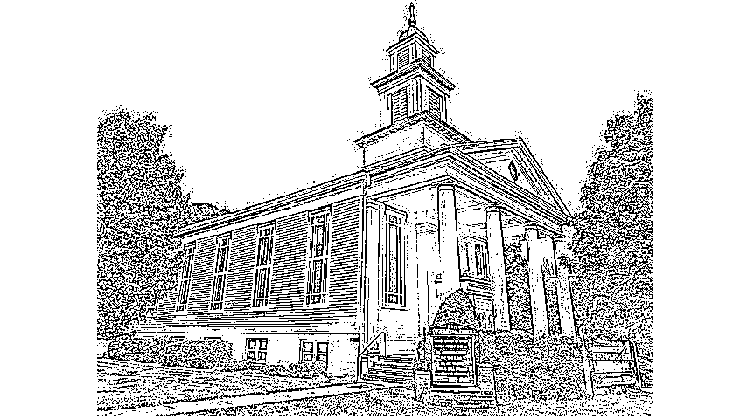

Connecting God’s People Through Love

September 2022
Sunday | Monday | Tuesday | Wednesday | Thursday | Friday | Saturday
 |  |  |  | 1 | 2  Elijah's Closet  10-2 | 3  Elijah's Closet  10-2
4 13th Sunday after Pentecost  Worship 10 AM  Communion  Trustees Mtg. after service | 5 | 6 | 7 | 8 | 9  Elijah's Closet  10-2 | 10  Elijah's Closet  10-2
11 14th Sunday after Pentecost  Worship 10 AM  Deacons Mtg. after service | 12 | 13 | 14  Elijah’s Closet  Volunteers Mtg. 4:45 | 15 | 16  Elijah's Closet  10-2 | 17  Elijah's Closet  10-2
18 15th Sunday after Pentecost  Worship 10 AM  Christian Ed.  Mtg. after service | 19  Church In Society Mtg.  6:30 @ Church | 20 | 21 | 22 | 23  Elijah's Closet  10-2  Prudential Board Mtg 3:30 via Zoom | 24  Elijah's Closet  10-2
25 16th Sunday after Pentecost  Worship 10 AM | 26 | 27 | 28 | 29 | 30

Revised Common Lectionary

The readings used at our weekly worship service and in most Mainline Protestant Churches and in Roman Catholic Churches are from a list of assigned readings known as The New Revised Common Lectionary. In our Congregational tradition, pastors are encouraged to use the assigned readings but it is not mandatory.

I personally prefer to follow the readings and I mainly focus on the Gospel lessons for my meditation. It gives me and you a structure through which we can study and learn from the teachings of the scripture of the Word (Logos) of God in our midst.

The readings for August: (You are encouraged to read them as well)

Date 1st Reading Alternate 1st 2nd Reading Gospel
and Psalm Reading and
Psalm
Thirteenth Sunday after Pentecost  September 4, 2022 | Jeremiah 18:1-11  Psalm 139:1-6, 13-18 | Deuteronomy 30:15-20  Psalm 1 | Philemon 1:1-21 | Luke 14:25-33
Fourteenth Sunday after Pentecost  September 11, 2022 | Jeremiah 4:11-12, 22-28  Psalm 14 | Exodus 32:7-14  Psalm 51:1-10 | 1 Timothy 1:12-17 | Luke 15:1-10
Fifteenth Sunday after Pentecost  September 18, 2022 | Jeremiah 8:18-9:1  Psalm 79:1-9 | Amos 8:4-7  Psalm 113 | 1 Timothy 2:1-7 | Luke 16:1-13
Sixteenth Sunday after Pentecost  September 25, 2022 | Jeremiah 32:1-3a, 6-15  Psalm 91:1-6, 14-16 | Amos 6:1a, 4-7  Psalm 146 | 1 Timothy 6:6-19 | Luke 16:19-31

From the Treasurer
July Offering Information

Monthly amount needed to meet the yearly budget of $85,325: $7,110

July Offering: $5,974

Many thanks to all of you for not only your money but your time and talents.

Marc

Moderator’s Message
September 2022

Happy September! As schools re-open with fewer and fewer pandemic protocols in place, we all celebrate the long-awaited “return to normalcy.” Our small but mighty flock has been busy this summer tending to our missions and ministry. Elijah’s Closet has had a makeover; we hosted Tai Chi classes for the community; Sunday Worship is in-person with hymn singing and traditional communion. The Pastoral Search Committee is preparing the final job details for an Assistant Pastor for Youth and Families to be advertised soon. We continue to believe that God is Still Speaking, and together we learn how to listen.

September Notes from almanac.com:

- 5—the first Monday in September—is Labor Day.
- 11 is Patriot Day, held in honor and remembrance of those who died on 9/11.
- 11 is also Grandparents Day.
- 17 is Constitution Day, celebrating the adoption of the U.S. Constitution, on
- September 17, 1787
- 21 is International Day of Peace. Observances range from a moment of silence
- at noon to peace walks, concerts, and volunteering in the community.
- 22 marks the start of fall! Autumnal Equinox occurs at 9:04 P.M. EDT on
- Thursday, the 22nd when there are nearly equal hours of daylight and darkness.
- 25 starts Rosh Hashanah, a Jewish holiday for the beginning of the new year.
- 29 is Michaelmas, a Celtic celebration marking the end of the harvesting season.

Psalm 18:32 God arms me with strength and makes my way perfect.

Dear Lord,
Thank you for the strength you give us to make it through the rough days.
You make the path perfect for our journey, and our hope is in you. Amen

Diane

A NOTE FROM
Janet

TRANQUILITY

In Paul’s letter to the Thessalonians Paul suggests that there is more that they need to do to live a life in Christ, he writes: “aspire to live a tranquil life”.

To be tranquil suggests a life of harmony, stillness, serenity, contentment and peace of mind. We probably all yearn for such a way of life! But turn on the news of the day and it is anything but tranquil. We are a divided nation and world; we see harm and destruction coming at us; we have demands placed on us in our family life that often mirrors the world situations. But I have met some tranquil people in my life’s journey and it was healing and heartfelt. Maureen was one of these people.

Tranquility has less to do with circumstances and more to do with our hearts ability to know who we are and, most importantly, whose we are. Jesus demonstrates to us what tranquility looks like. As we read in John’s Gospel, the night before his death, Jesus gathered his friends and washed their feet in calmness and service that extended his love to them. In the horror of the day Jesus gave to his friends an example of loving service. The love that comes from the heart given to us by God’s grace. If we are truly followers of Christ, we too can live a tranquil life in our heart by always loving and forgiving – not judging – but by expressing our service of love to all who enter our life. Jesus lived a tranquil life even to the end and so can we!

Pastor Janet

Can Things Get Any Worse?

A quip on Social Media asked: “Who would have thought that we’d have to ask which Pandemic?” as variants of Covid continue to cause serious illness, hospitalizations and even deaths, but now there’s a new public health emergency around a mutated virus named “monkeypox”! Plus, the polio virus has just been reported in New York State again.

Although the American Economy seems to be recovering – with 0 percent inflation reported for July and the lowest unemployment rate in decades – average Americans are struggling with the increased prices of gas, groceries, housing, utilities, repair services and almost everything else... while paychecks haven’t kept up. The changes and life disruptions that
began in March 2020 still haven’t let us return to life as it once was. Many have experienced
too much loss: loss of loved ones, loss of health, loss of income, loss of job, loss of savings,
loss of housing, loss of hope. Average citizens, including church members, have lost of a
sense of “normal” – feeling worn out, fragile, easily upset, wanting to escape the stress and
anxiety that can sometimes be overwhelming.

“More people are dying of drug overdoses in the United States today than at any point in
modern history.” (New York Times Opinion, Jeneen Interlandi, June 24, 2022) Across America,
including Central New York, there has been an increase in substance abuse, domestic
violence, marital & relationship break-ups.... All happening more under economic and social
stresses, and all affecting our communities, our families and our own sense of well-being.
Your church can help.

The Susquehanna Association of churches in the United Church of Christ, New York Conference wants to support you and your family. A Counseling Assistance program will reimburse half, up to $50, of up to 6 counseling sessions provided by a licensed New York State therapist.

All you have to do is apply! Your request will be anonymous, only reviewed by Counseling Assistance Board members, adhering to strict confidentiality. Members of UCC Churches in the Susquehanna Association, and persons referred by members and clergy, are eligible to receive assistance.

Counseling Assistance Board of Susquehanna Association, UCC Churches

Email: counselingsany@gmail.com

Rev. Dr. Janet Adair Hansen, Moderator - Kathy Estey - Rev. Dr. Janet Schwengber

Updates from the Trustees

I’d like to keep you informed about issues we are working on at the church. First, Webster will be sealing our driveway before winter sets in. We have hired S&S Landscaping from Sidney to trim the Memorial Garden which has become overgrown. S&S Landscape will also in the spring give us a quote on redoing the front of the church which has become very overgrown and probably most will have to be pulled out and replaced.

One of our biggest concerns is the water collecting in the Fellowship room by the boiler room door. We believe the cause is an eaves trough that is plugged with debris and have contacted Gutter Experts from Bainbridge to look at the issue and put a leaf cover over the trough to keep out any debris. With heavy rain water was coming down the inside wall like a waterfall. The stones in the front by the doors and steps need pointing up. I haven’t found a person yet to do this job.

Of course, we have a wish list - a long one. The front of the church needs painting and the Southside of the church the wood boards are rotting and the insulation is sagging behind the rotting boards. Please say a prayer that someday we will be able to take this off our wish list.

Lorraine Miller, Chairman of the Trustees

