THE CONNECTION
December 2022

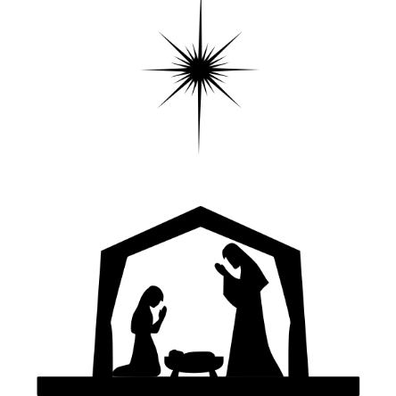

Connecting God’s People Through Love

December 2022
Sunday | Monday | Tuesday | Wednesday | Thursday | Friday | Saturday
 |  |  |  | 1 | 2  Elijah's Closet  10-2 | 3  Elijah's Closet  10-2
4 2nd Sunday of Advent  Worship 10 AM  Communion  Trustees Mtg. after service | 5 | 6 | 7  Elijah’s Closet  Volunteers Mtg. 4:45 | 8 | 9  Elijah's Closet  10-2  Prudential Board Mtg. | 10  Elijah's Closet  10-2
11 3nd Sunday of Advent  Worship 10 AM  Deacons Mtg after service | 12 | 13 | 14 | 15 | 16  Elijah's Closet  10-2 | 17  Elijah's Closet  10-2
18 4th Sunday of Advent  Worship 10 AM  Christian Ed.  Mtg. after service | 19  Church In Society Mtg.  6:30 @ Church | 120 | 21 | 22 | 23  Elijah's Closet  10-2 | 24  Christmas Eve  Elijah's Closet  Closed
25 Christmas Day  Worship 10 AM | 26 | 27 | 28 | 29 | 30  Elijah's Closet  10-2 | 31  New Year’s Eve  Elijah's Closet  Closed

Revised Common Lectionary

The readings used at our weekly worship service and in most Mainline Protestant Churches and in Roman Catholic Churches are from a list of assigned readings known as The New Revised Common Lectionary. In our Congregational tradition, pastors are encouraged to use the assigned readings but it is not mandatory.

I personally prefer to follow the readings and I mainly focus on the Gospel lessons for my meditation. It gives me and you a structure through which we can study and learn from the teachings of the scripture of the Word (Logos) of God in our midst.

The readings for August: (You are encouraged to read them as well)

Date 1st Reading Alternate 1st 2nd Reading Gospel
and Psalm Reading and
Psalm

Second Sunday of Advent  December 4, 2022 | Isaiah 11:1-10 | Psalm 72:1-7, 18-19 | Romans 15:4-13 | Matthew 3:1-12
Third Sunday of Advent  December 11, 2022 | Isaiah 35:1-10 | Psalm 146:5-10  or  Luke 1:46b-55 | James 5:7-10 | Matthew 11:2-11
Fourth Sunday of Advent  December 18, 2022 | Isaiah 7:10-16 | Psalm 80:1-7, 17-19 | Romans 1:1-7 | Matthew 1:18-25
Nativity of the Lord - Proper I  December 24 & 25, 2022  Christmas Eve, Morn, or Mid-Day | Isaiah 9:2-7 | Psalm 96 | Titus 2:11-14 | Luke 2:1-14, (15-20)
Nativity of the Lord - Proper II  December 24 & 25, 2022  Christmas Eve, Morn, or Mid-Day | Isaiah 62:6-12 | Psalm 97 | Titus 3:4-7 | Luke 2:(1-7), 8-20
Nativity of the Lord - Proper III  December 24 & 25, 2022  Christmas Eve, Morn, or Mid-Day | Isaiah 52:7-10 | Psalm 98 | Hebrews 1:1-4, (5-12) | John 1:1-14

Moderator’s Message

December 2022

The blessed season of Advent is upon us as we await the birth of our Savior with anticipation!
Our church family will rejoice throughout the season with special events and worship. The Sanctuary is decorated. Donations for Christmas flowers in honor or memory of individuals may be made to Fran Robinson through December 11th.

We will host an organ recital by Curt Sather at 3:30 pm on Sunday, December 18, 2022. Earlier that day we will celebrate the Sunday School Children’s Christmas presentation during worship.

Our Christmas Eve service will be an in-person service. More details will follow.

Christmas Day worship will be a 30-minute service of carols and prayers provided by Steve Sehen and Pastor Janet. There will not be Sunday School on Christmas Day, but it is “Flannel and Sweats” day. Come dressed casually and warmly to celebrate the reason for the season.

Please take time to read and prayerfully consider the letter and return card you have received from the Prudential Board and Trustees. The new year brings the anticipation that we will work together to build our presence in the community through mission and ministry, but we need commitment and consensus to move forward. As always, your financial support is not only appreciated, but vital to our success.

On behalf of the Prudential Board and our church leadership, I extend to each of you our prayers and best wishes for a blessed and healthy Christmas season.

Diane Meredith, Co-Moderator

Dear Lord,
May we be like the Wise Men who were guided to You by a star. Give us wisdom to seek You, light to guide us to You, courage to search until we find You and generosity to lay our gifts before You, our King and our God forever and ever. Amen.
https://www.beliefnet.com/

A NOTE FROM
Janet

St. Nicholas

December 6th is St. Nicholas day. As a little girl, I would place my list of what I wanted for Christmas for him to pick up on this day. I was told by my parents that he would deliver the list to Jesus who would then tell Santa Claus what gifts to deliver to me on December 24th (when we celebrated Christmas).

St. Nicholas was a real person. He was the Bishop of Myra in the fourth century. Over the years we transformed St. Nicholas into Father Christmas or Santa Claus. It is believed that St. Nicholas rescued three young girls whose father, who could not pay a marriage dowry, was going to sell them to prostitution. Nicholas tossed three bags of gold through their window. This was enough to pay the marriage dowry for each girl. As a result, gifts became a major part of St. Nicholas or today we know him as Santa Claus.

The missing part of this story is that we have dismissed Jesus from our thoughts of gift giving. But St. Nicholas is quoted as saying: “The giver of every good and perfect gift calls us to mimic God’s giving of grace to us through faith.”

Giving gifts at Christmas is a time for us to understand that the grace of God is given to us as the perfect gift! May all your gifts be blessed with grace!

Pastor Janet

IRT Program (Innovative Readiness Training)
Free Medical Care
This program is sponsored by the Department of Defense and provides 11 days’ worth of no-cost medical care for the residents of Delaware County. It will be held July 10-21, 2023 at Walton high School and is supported by Delaware County and UHS.
Major Daniel LaVorgna is the Program Manager for the Army. They currently have 18 projects running this year across the United States. This program encourages their medical personnel to stay mission ready by providing medical services in local communities.
In Walton, they will provide no-cost, no appointment, walk in medical assessment, physicals, prescriptions, basic optometry and dental services, and veterinary spay/neutering services.
More information will be available in the Spring.

First Words
Why aren't people coming back?

A letter to pastors and churchgoers who wonder what happened to the prepandemic church they knew.
by Peter W. Marty

Dear friend,
I am going to assume you're a positive person who enjoys people, radiates goodness, and thrives on hope. I'm also going to assume you're familiar with discouragement. So, tell me if I have this much right: sometime in the last year you looked out over the sanctuary and congregation you love, and you wondered, what happened to the people? Why did so many kiss congregational life good-bye?

If you've contacted any of these absent parishioners, you may well have learned that they're doing just fine. Their weekends are active and full. They either endured COVID or escaped it altogether. They sound healthy and well. The topic of church may have surfaced briefly when you spoke, but it didn't seem to be very high on their priority list. So, what should you do?

Well, keep the doors of your church and heart wide open. Don't write off anyone's place in your community unless they insist on it. Restarting a lapsed habit of any kind, remember, can be more difficult than creating and cultivating a brand-new one. I wouldn't overanalyze why all sorts of people aren't showing up. Your church may be as good as any. Let's not forget the growing secularization of culture and rising religious indifference staring us all in the face. Much of the public perceives faith as having limited social value. "We now live in a time," says Andrew Root, "where the very idea that God is real and present in our lives is no longer accepted. Indeed, it's widely contested." Skepticism about the benefits of religious community has caused many people to quit looking to the church for personal meaning or identity.

Because you are a person of faith who leans into Christian community, however, there are somethings to keep in mind when you're discouraged. First, remember that God has given the church a bigger and better hope than what the world lives by. How you communicate this beautiful idea that we follow a light brighter than the flicker of our own little bulb is up to you. Second, don't forget to love your Christian community as you find it, not merely as you wish it were. That's Dietrich Bonhoeffer's idea, not mine. He also reminds us that there's no way to know Christ apart from Christian community. Christus als Gemeinde existierend — Christ exists as community. Anybody can talk up their love for Jesus. But the church is the one place where we actually meet the living and present Christ. Third, remind yourself that your church needs to welcome and accept people for who they are — if it is to be any kind of magnet in your community — and then love them into who they get to become in Christ. Fourth, keep looking for ways to grow and share the bubbling energy that ought to be evident in your church when people come together around a shared purpose. Émile Durkheim coined the term collective effervescence to describe what happens when communal gatherings foster a deep religious experience.

Finally, delight in every sign of your congregation’s faithfulness. Fixating on who's not in the pews is a worthless and suffocating exercise. There is no convincing anybody of their need for Christian community. They have to want it. And their best chance for discovering that desire may come from observing the joy
that's in you.

Your companion on the journey, Peter

Peter W. Marty is the CENTURY'S editor/publisher.
December 2022 The Christian Century

Special Christmas Events at First Congregational

Sunday, December 18 - Christmas Play offered by the Sunday School during worship, followed by a dish to pass after worship.

Sunday, December 18 - 3:00 PM – Organ Recital by Curt Sathar, in the Sanctuary

Saturday, December 24th (Christmas Eve) - Carillon Music with gifts from the Sunday School in the parking lot prior to the evening service. Followed by Christmas Eve service in the Sanctuary

Sunday, December 25 “Flannel and Sweats” Christmas Day service 10:00 am, carol sing-a-long

Thanksgiving Meal

The Thanksgiving Community Meal was very successful. We served approximately 230 meals to members of the community. Charlene Gregory delivered 15 extra meals to the staff at Delaware Valley Hospital. Thanks to everyone who participated in the preparation and serving of the meal. Photos courtesy of Loraine Davila.

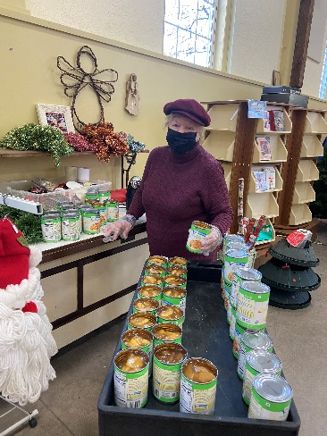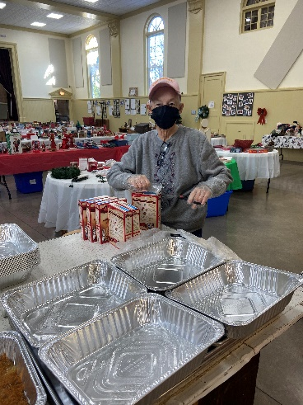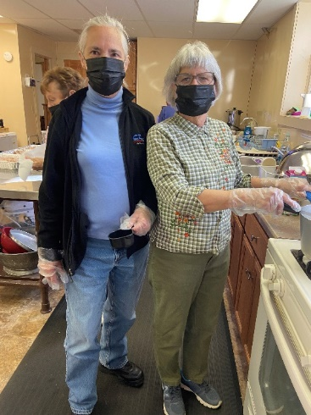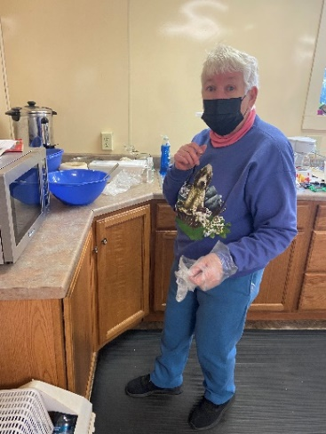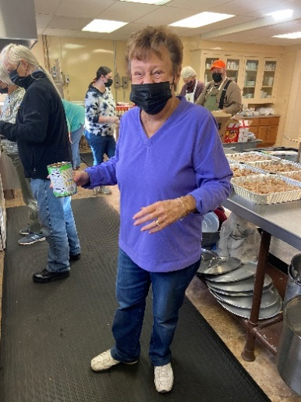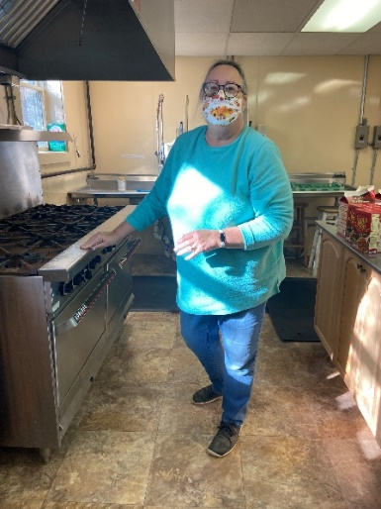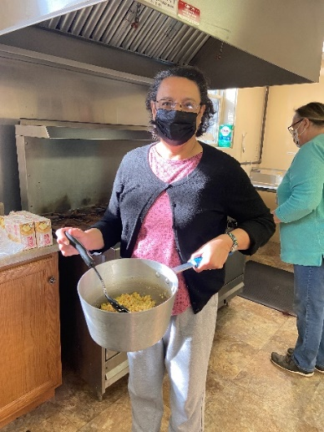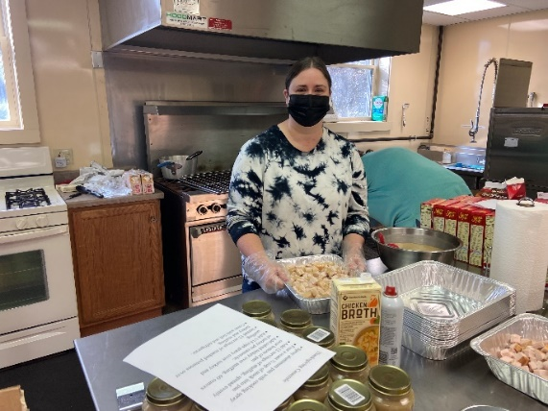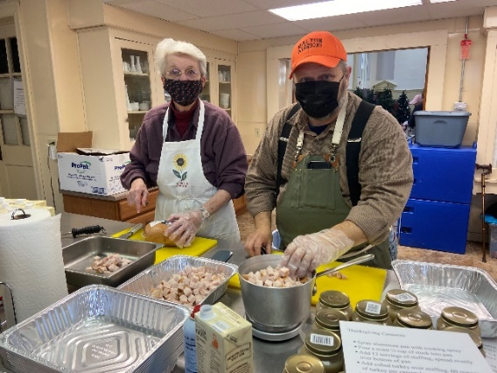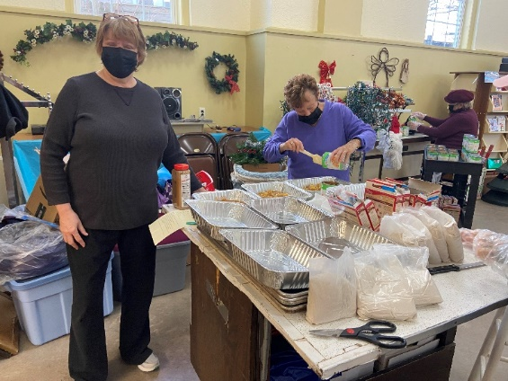

Hanging of the Greens

On Sunday, November 27th, members of our church community decorated the Sanctuary for the Christmas Season. Here are some photos (again courtesy of Lorrain Davila) of our church members in action.

