THE CONNECTION
January 2023

Connecting God’s People Through Love

January 2023
Sunday | Monday | Tuesday | Wednesday | Thursday | Friday | Saturday
1 New Year’s Day  1st Sunday after Christmas  Worship 10 AM  Communion  Trustees Mtg. after service | 2 | 3 | 4 | 5 | 6  Elijah's Closet  10-2 | 7  Elijah's Closet  10-2
8 1st Sunday after Epiphany  Worship 10 AM  Deacons Mtg after service | 9 | 10 | 11  Elijah’s Closet Mtg.  4:45 | 12 | 13  Elijah's Closet  10-2 | 14  Elijah's Closet  10-2
15 2nd Sunday after Epiphany  Worship 10 AM  Christian Ed.  Mtg. after service | 16 | 17 | 18 | 19 | 20  Elijah's Closet  10-2 | 21  Elijah's Closet  10-2
22 3rd Sunday after Epiphany  Worship 10 AM | 23  Church In Society Mtg.  6:30 @ Church | 24 | 25 | 26 | 27  Elijah's Closet  10-2  Prudential Board Mtg.  3:30 | 28  Elijah's Closet  10-2
29  Worship 10 AM  Annual Meeting  After Service | 30 | 31

Revised Common Lectionary

The readings used at our weekly worship service and in most Mainline Protestant Churches and in Roman Catholic Churches are from a list of assigned readings known as The New Revised Common Lectionary. In our Congregational tradition, pastors are encouraged to use the assigned readings but it is not mandatory.

I personally prefer to follow the readings and I mainly focus on the Gospel lessons for my meditation. It gives me and you a structure through which we can study and learn from the teachings of the scripture of the Word (Logos) of God in our midst.

The readings for January: (You are encouraged to read them as well)

Date 1st Reading Alternate 1st 2nd Reading Gospel
and Psalm Reading and
Psalm

First Sunday after Christmas Day  January 1, 2023 | Isaiah 63:7-9 | Psalm 148 | Hebrews 2:10-18 | Matthew 2:13-23
Baptism of the Lord  January 8, 2023  First Sunday after the Epiphany | Isaiah 42:1-9 | Psalm 29 | Acts 10:34-43 | Matthew 3:13-17
Second Sunday after the Epiphany  January 15, 2023 | Isaiah 49:1-7 | Psalm 40:1-11 | 1 Corinthians 1:1-9 | John 1:29-42
Third Sunday after the Epiphany  January 22, 2023 | Isaiah 9:1-4 | Psalm 27:1, 4-9 | 1 Corinthians 1:10-18 | Matthew 4:12-23
Fourth Sunday after the Epiphany  January 29, 2023 | Micah 6:1-8 | Psalm 15 | 1 Corinthians 1:18-31 | Matthew 5:1-12

From the Treasurer

October and November Offering Information

Monthly amount needed to meet the yearly budget of $85,325: $7,110

October Offering: $2.695.00
November Offering: $4,052.00

Many thanks to all of you for not only your money but your time and talents.

Marc

Moderator’s Message

Happy New Year! Have you made any resolutions for 2023? In the past decade, after years of failing to successfully turn any one resolution into a life-long, life-changing practice, I now resolve each year instead to simply be a better person each day. Although there are bad days, I find this one simple goal keeps me growing spiritually, mentally, socially, and emotionally. As co-moderator, I am now thinking about how our church can grow. The news app on my phone recently offered the following article:

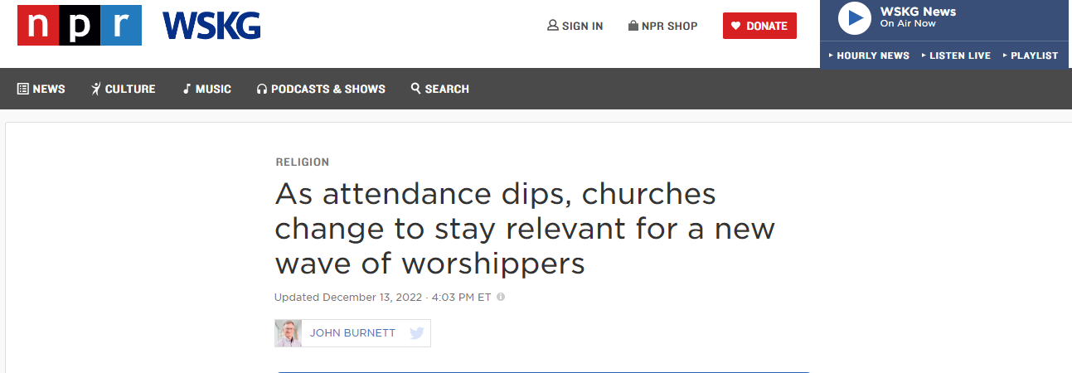

It’s a lengthy read, but you can find it here: https://www.npr.org/2022/12/10/1141010320/as-attendance-dips-churches-change-to-stay-relevant-for-a-new-wave-of-worshipper
The reality for churches in 2023 is summarized well:
“This impulse — this urgency — to try something new is being felt throughout the Christian church. Once-booming evangelical churches are worried about declining numbers. But liberal mainline protestants like the Lutherans, Methodists, Presbyterians, and Episcopalians are hemorrhaging members.
Consider Knoxville's Marble City United Methodist Church. The stained-glass windows are still there, but today the structure houses an architectural firm and a Golden Roast coffee shop. The congregation abandoned the building in 2011 and merged with another Methodist church because of steadily declining membership. The building was briefly home to a Messianic Jewish congregation before its current incarnation.
"Every year we close anywhere between two and five churches. Every single year," says Methodist pastor Bradley Hyde, sitting at a table sipping java while the milk steamer hisses behind the counter. "I think people were already wanting to leave church, and Covid gave them a great opportunity to say, 'Goodbye.' I'm not the only pastor who has noticed that, but a lot of people have just not come back."”
The solution offered by the church in Tennessee—a most unconventional shift to worshipping while working a farm—is not the solution that can work for every church. But each church has the opportunity to reimagine and redefine what church means in its unique community. Repurposing the church facilities is another contemporary idea gaining in popularity. Not every church can rent space to an architectural firm and a coffee shop, but every community has needs that perhaps only the church can address.
This month I pray that we can come together in 2023 with open, inquiring minds and innovative thinking to discern the pressing needs of our community and then resolve to rethink how our church can be reimagined for the next generations. I look forward to hearing your thoughts.
Best wishes for a most wonderful new year!
Diane Meredith

A NOTE FROM
Janet

Always Rejoice!

On the third Sunday of Advent, we lit the pink candle. The third Sunday is called Gaudate Sunday, from the Latin meaning “Rejoice”. It is now the New Year, are we still rejoicing? The effects of the pandemic, the killings we hear of so often, the war in Ukraine, the uncertainty of our economy, and the threats of the effects of global warming all wear on our ability to rejoice. At Christmas we celebrated the incarnation, God-with-us, and on Epiphany we celebrate the welcoming of all people into God’s indwelling gift of Divine Love. Such hopeful joy, however, can be difficult for many people. Let us also remember that even Jesus suffered in our world as he came to save us from ourselves.

It is at this time of a New Year that we need to begin to recognize that we are not left to ourselves. We are the members of the body of Christ and if one part suffers all parts suffer. But we also belong to a community of faith that celebrates God’s presence among us – especially in times of hardship and difficulty. We are all called to bear witness to our joyful hope for a world in desperate need. It is as St. Paul says to the Philippians (4:4) “Rejoice in the Lord always; again, I say rejoice.”

Have a joy-filled New Year!

Pastor Janet

IRT Program (Innovative Readiness Training)
Free Medical Care
This program is sponsored by the Department of Defense and provides 11 days’ worth of no-cost medical care for the residents of Delaware County. It will be held July 10-21, 2023 at Walton high School and is supported by Delaware County and UHS.
Major Daniel LaVorgna is the Program Manager for the Army. They currently have 18 projects running this year across the United States. This program encourages their medical personnel to stay mission ready by providing medical services in local communities.
In Walton, they will provide no-cost, no appointment, walk in medical assessment, physicals, prescriptions, basic optometry and dental services, and veterinary spay/neutering services.
More information will be available in the Spring.
You Are Invited to Attend
The First Congregational Church,
United Church of Christ, Walton

Annual Meeting
Sunday, January 29, 2023
Following Sunday Services
(approx. 10:30 am)

If you have any questions, please feel free to contact Co- Moderators
Nancy Grotevant (onelongroad2@hotmail.com), Diane Meredith (mereditd@gmail.com),
or church secretary Dana Baker (secretary@uccwalton.com). You may also call the Church Office at 607-865-4066

An informational packet including committee reports and budgetary information will be mailed in advance of the meeting.

